Protect Your Company by Partnering with ThePEOPeople.com and SBE 479 to Minimize and Manage Safety Risks
At ThePEOPeople.com and SBE479, we are committed to partnering with clients to help protect their businesses. To that end and speciﬁcally to support our partnership with clients on workers’ compensation insurance for worksite employees, SBE479 has risk consultants dedicated to helping clients minimize and manage safety risks.
Our Risk Control consultants can help you reduce the likelihood of worker injury and many of the direct and indirect expenses associated with worker injuries and workers’ compensation claims. This can positively impact your workers’ compensation loss history and reduce the probability of damage to equipment and facilities while minimizing other indirect costs associated with workplace injuries.
SBE479 Risk Control services include:

• equipment or work practices that can lead to employee injury and workers’ compensation losses.
Safety training guidance for management personnel in a train-the-trainer format to help you conduct more effective employee trainings.

- Loss trending and analysis to identify where speciﬁc problems may be occurring in the workplace and provide alternatives to prevent recurrence.
- Administrative and engineering recommendations to minimize hazards in the workplace.
- Review of existing safety programs and guidance on improving their effectiveness.
- Safety program templates, which you customize with your own content.
- Access to an extensive safety DVD library with over 200 titles, as well as printed toolbox/tailgate safety meeting material. Additionally, SBE479 Learn provides access to online safety training modules for an additional fee.
- Accident investigations to identify cause and recommend corrective action for high loss injuries or incidents involving multiple employees.

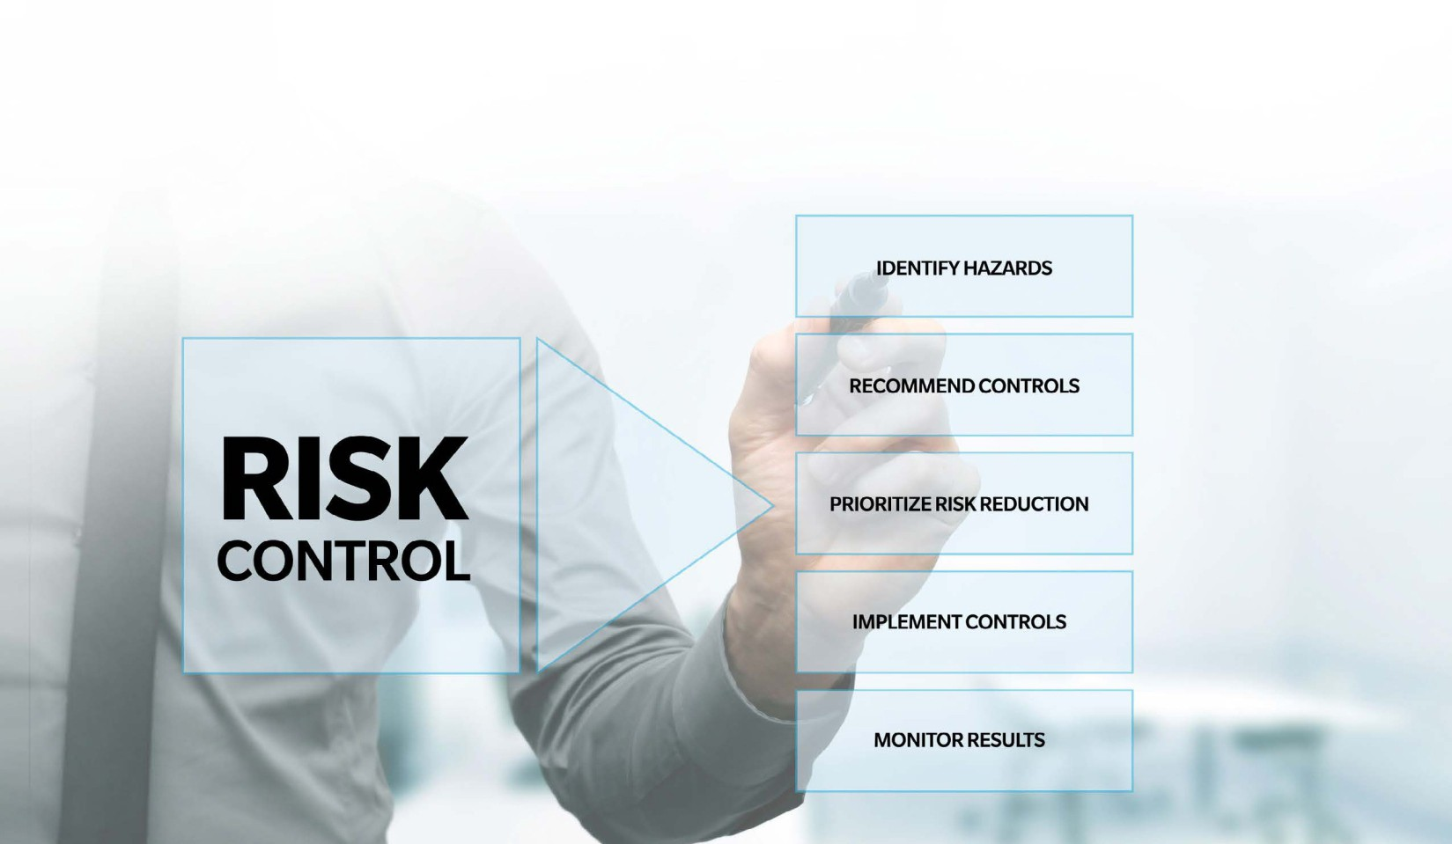

FOR MORE INFORMATION CONTACT US
Visit ThePEOPeople.com
or call our representative at 844.479.TEAM

