Employment Practices Risk Management
Protecting Your Business Every Step of the Way
Employment-related claims are a standard hazard of being an employer. Approximately 90,000 discrimination charges are ﬁled with the Equal Employment Opportunity Commission (EEOC) every year. Average settlement amounts are more than $250,000 , and average judgments are up wards of $450,000. That doesn’t include the extra time, effort and stress taken to resolve the situation.
With hiring people in multiple states, we run into different laws and regulations in each case. So, it’s very helpful to have SBE 479 there to manage that process.
Ethan Brown
CEO
Beyond Meat
Employment Practices Risk Management helps protect your business from many employer liabilities such as discrimination, wrongful termination, unlawful retaliation, and harassment claims. Our comprehensive program helps prevent issues from arising, and supports you in the event of a claim with insurance coverage and claims management expertise.

Claims Prevention
with expert guidance
Claims Coverage
with comprehensive insurance
Claims Mitigation
with management and advice

- HR team provides guidance on best practices and regulatory changes.
- SBE479 Reference Library, integrated with the SBE479 platform.
- Web applications for employment law determinations.
- Legal Hotline for advice from employment law experts.
- $1 million employment practices liability coverage3 .
- Active management of claims reporting and insurance adjusters.
- Legal team manages and reviews claims and invoices.
- Pre-negotiated fees for external attorneys.

1EEOC website, https://www.eeoc.gov/eeoc/statistics/enforcement/charges.cfm, accessed as of November 10, 2017.
22015 Hiscox Guide to Employee Lawsuits, Hiscox Inc., 2015.
3Speciﬁc terms & conditions of coverage (deductibles, secondary coverage, etc.) are provided and reviewed with prospects in the course of preparing a custom- ized quote. Cover age does not extend to, among other items, wage & hour or breach of contract claims. Contact your sales rep for additional information.

SBE479 involvement makes an impact
- 80+% of claims handled internally resulted in zero cost to clients.
- Average defense and settlement costs are 90% lower than national av. erages

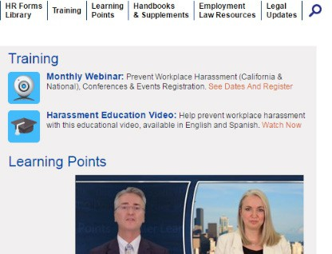
SBE479 Reference Library
  - Web-based training modules.
  - Employment policies, handbooks and supplements.
  - Employment law resources, state-speciﬁc HR forms & legal updates.

Legal Hotline for advice from employment law experts
  - Consultations for topics such as wage & hour classiﬁcations, non-compete clauses and background checks.
  - Assists in reducing risk exposure to employment-related claims.
  - Conﬁdential communications, protected by attorney-client privilege.
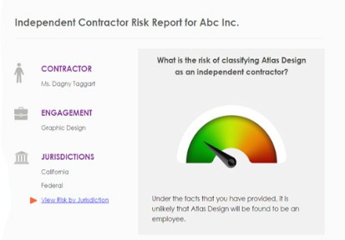
  - Provides assistance beyond the scope of SBE479’s HR advice.

Artiﬁcial Intelligence for employment law determinations
  - Independent Contractor and Overtime: Guided decision- making on contractor and exemption status.
  - Wage & Hour and Leave: Policy compliance veriﬁcation and guidance.
  - Onboarding: Compliant documentation production for employment applications, offer letters and non-disclosure agreements.

Pre-negotiated fees for external attorneys
  - Attorney demand letters, charges of discrimination, and wage & hour4claims.
  - Discounted rates for matters that escalate to litigation.
  - Flat-rate fees for business needs such as incorporation, lease reviews, patent ﬁlings and conﬁdentiality agreements.

4SBE479’s EPLI policy does not cover Wage and Hour claims, but customers may still use our ﬁxed fee program for their beneﬁt.

FOR MORE INFORMATION CONTACT US
Visit ThePEOPeople.com
or call our representative at 844.479.TEAM

