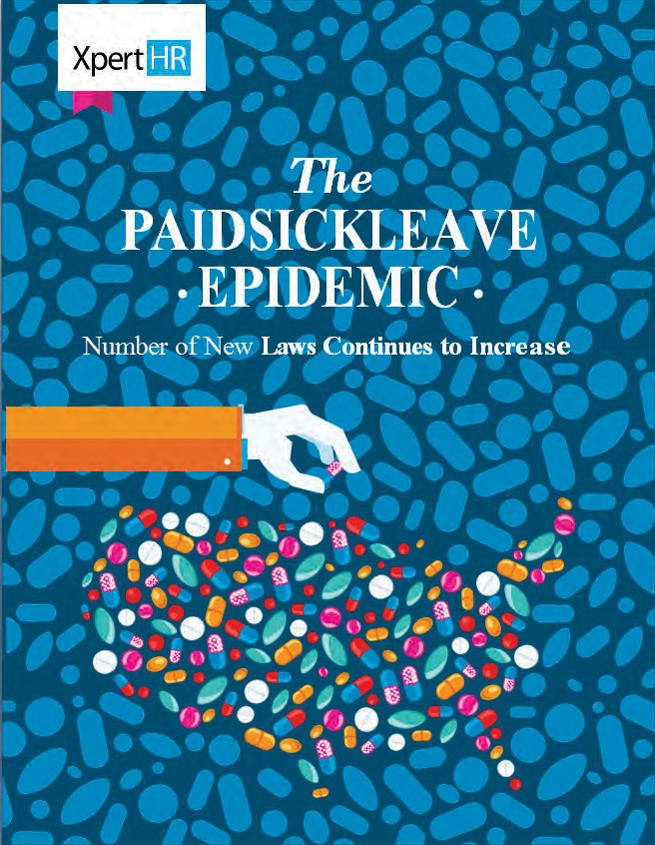

ThePEOpeople.com

The Paid Sick Leave Epidemic:
Number of New Laws Continues to Increase
States and Municipalities Take Matters into Their Own Hands; Some Embracing, Others Banning Paid Sick Leave Laws

Use this guide to:

Understand the paid sick leave trend across the United States;
About SBE479
and ThePEOPeople.com
ThePEOPeople.com is a community outreach organization paid by and sponsored by certain approved and certiﬁed 479 providers. Our function is help make small and medium sized businesses become aware of this fundamentally important and potentially game changing legislation. It was passed by Congress for a good reason - to make American Businesses more competitive and more proﬁtable by reducing risk to owners, liabilities and red tape to small and medium companies, and to do things you just couldn’t do before this law. These advantages stem from a very simple concept – allow smaller business access the buying power and systems of larger companies and to also allow you to actually relieve yourselves of various liabilities and responsibilities. Make no mistake about this – it is important.

Learn about the variations and similarities
in US paid sick leave laws;

Get practical advice (including a case study) to manage and comply with this trend.

More than 41 million people, accounting for about 36 percent of private sector workers in the United States, do not have the ability to earn paid sick leave, according to the National Partnership for Women andFamilies. In 2015, President Obama signed an Executive Order (EO) requiring that employees working on federal contracts and subcontracts earn paid sick leave; however, the EO does not extend to the private sector, generally.
Paid Sick Leave Laws and Their Eﬀective Dates
Year | # Laws  Eﬀective | jurisdiction/Eﬀective Date
2007 | 1 | SanFrancisco,CA(Feb. 5,2007)
2008 | 1 | District of Columbia (May 13,2008)
2012 | 2 | Connecticut(Jan. 1,2012) Seattle, WA(Sept. 1, 2012)
2014 | 5 | Sea Tac, WA (Jan. 1,2014)  Portland, OR (Jan. 1,2014) Jersey City, NJ (Jan. 24,2014) New York City, NY (Apr. 1, 2014) Newark, NJ (June21,2014)
2015 | 13 | Passaic, NJ(Jan. 1,2015) East Orange, NJ(Jan. 7,2015) Paterson, NJ (Jan. 9,2015) Irvington, NJ (Jan. 28,2015) Oakland, CA (Mar. 2,2015) Mont clair, NJ (Mar. 4,2015) Trenton, NJ (Mar. 4,2015) Philadelphia, PA (May 13,2015) Bloomﬁeld, NJ (June30,2015) Massachusetts (July1,2015) California (July 1,2015): Main provisions of the law (notice posting provisions eﬀective Jan. 1,2015) Emeryville, CA(July1,2015) Los Angeles, CA (July1,2015)– Larger hotels(smaller hotels eﬀective July 1,2016)
2016 | 8 | Oregon(Jan. 1,2016) New Brunswick, NJ(Jan. 6,2016) Tacoma, WA (Feb. 1,2016) Elizabeth, NJ(Mar. 2,2016) Los Angeles, CA(July1,2016)– Larger employers(smaller employers eﬀective July 1,2017) San Diego, CA (July 11,2016) Plainﬁeld, NJ(July 15,2016) Montgomery County, MD (Oct. 1, 2016)
2017 | 9  As of Oct. 1, 2016 | SantaMonica,CA(Jan. 1,2017) Spokane, WA(Jan. 1,2017) Vermont(Jan. 1,2017)–Larger employers (smaller employers eﬀective Jan.1,2018) Morris town, NJ(Jan. 11,2017) Minneapolis, MN(July1,2017) Chicago, IL(July 1,2017) St. Paul, MN (July 1,2017)–Larger employers(smaller employers eﬀective Jan.1,2018)  Cook County, IL (July1,2017) Berkeley, CA (Oct. 1, 2017)

Without federal legislation in place, several states and local jurisdictions have taken matters into their own hands by creating their own paid sick leave laws to protect employees who may otherwise be forced to choose between going to work sick and losing pay or, in some cases, their jobs. What started out in 2007 as a small, local movement in San Francisco, has gained momentum and become an emerging trend across the United States (see box). As of October 1, 2016, ﬁve states, the District of Columbia and more than 30 municipalities have passed paid sick leave laws aﬀecting private employers, and the paid sick leave legal landscape continues to change rapidly. Many of these laws are already in eﬀect. Others, such as those in Vermont; Spokane, Washington; Minneapolis, Minnesota; and Chicago, Illinois, take eﬀect in 2017.

Interestingly, some states, including Michigan and Indiana, have gone in the opposite direction, banning cities from passing paid sick leave laws via a municipal preemption restriction. To see what states have adopted such preemption laws, see Municipal Preemption Laws by State (free registration required).

To keep up with the many new state and local paid sick laws, view the SBE 479 HR 50-State & Municipality Quick Reference Chart
(free registration required).

What Paid Sick Leave Laws Mean for Employers

When an employer operates or has employees in a jurisdiction that requires paid sick leave, the employer needs to carefully check the law’s requirements. For employers that operate in multiple locations that have paid sick leave laws, this can be a daunting task, as each law has its own standards regarding which employees are covered, which employers must comply, how employers must comply and more.

While many of the laws share commonalities, they all have unique provisions that force employers to monitor changes not only to their state laws, but also to their local laws. Then an employer must ﬁgure out if and how these laws interact with each other (and in some cases, other laws) and adjust business practices accordingly. Multi-jurisdictional employers need to consider whether they want to provide all employees, regardless of their location, with the most generous sick leave policy or else administer a patchwork of policies depending on where the employees work.

This white paper provides employers with a snapshot of the variations and similarities in paid sick leave laws across the jurisdictions, particularly with respect to:
- Employer coverage;
- Employee eligibility;
- Qualifying reasons for leave;
- Accrual;
- Minimum increment of leave usage;
- Notice and documentation requirement;
- Compensation;
- Carryover; and Interaction with other leave-related laws.

Who Must Comply
Employer coverage varies greatly from jurisdiction to jurisdiction. These variations run the gamut from how many employees the employer needs to have, to who is considered an employee, to even the type of industry the employer needs to be in. Here are just a few examples of the range in these laws relating to employer coverage:

Employers with just one employee must provide paid sick leave in jurisdictions such as California¹; the District ofColumbia; Montgomery County, Maryland; Newark, New Jersey; San Francisco and San Diego, California; and Tacoma,Washington.
In contrast, only employers with a speciﬁed number of employees must provide paid sick leave in jurisdictions such as Connecticut (50+ employees); New York City, New York (5+ or one or more domestic worker); Philadelphia, Pennsylvania (10+ and chain establishments); Portland, Oregon (6+); and Seattle, Washington (5+).

1 A caveat to California’s law is that while an employer only needs one employee to be covered under the law, that employee
must perform 30 days of work in California, for the same employer, in a year. Therefore, if an employer has 50 employees in Washington and one employee that occasionally works in California, the employer will need to carefully monitor how many days per year the one employee works in California. Once the employee hits 30 days, the employer becomes a covered employer.

The deﬁnition of employee for employer coverage purposes diﬀers from jurisdiction to jurisdiction, and in certain jurisdictions can be quite broad. For example, Massachusetts employers must count full-time, part-time, seasonal and temporary employees, regardless of location or eligibility for paid sick leave. In Seattle, on the other hand, employers must only count full-time equivalent employees (regardless of location or eligibility) who work 240 hours or more per calendar year within Seattle.

In Long Beach, California, and SeaTac, Washington, the laws limit employer coverage to hotel employers or certain hospitality and transportation industry employers.

The rules concerning how to count employees for employer coverage purposes are also deﬁned under certain laws. For example, in the District of Columbia, to determine how many employees are in its employ, an employer must look at the average number of monthly full-time equivalent employees (FTEs) it employed in the prior calendar year. This number is computed by adding the total number of FTEs working in the District of Columbia at the start of each month of the prior year and then dividing by 12.
It is important for an employer to realize that certain laws speciﬁcally exempt certain employers from coverage. For example, in Connecticut, speciﬁed manufacturers or nationally chartered 501(c)(3) organizations that provide recreation, child care and educational services are exempted from complying with the state’s law, with limited exceptions.

In some jurisdictions, the law diﬀerentiates requirements based on employer size. While employers of all sizes are covered under the law, “larger” employers must provide paid sick leave and “smaller” employers must oﬀer unpaid sick leave. For example,Massachusetts employers with 11 or more employees are required to oﬀer paid sick leave, while those that have 10 or fewer employees must oﬀer unpaid sick leave. Similarly, Minneapolis, Minnesota, requires employers with six or more employees to provide paid sick leave and smaller employers to provide unpaid leave. Therefore, in Massachusetts, Minneapolis and locations like them, no employer is fully oﬀ the hook from sick leave obligations.

Which Employees May Take Leave

While the speciﬁc criteria for an employee to be eligible to accrue sick time vary by location, most laws require that employees (including part-time and temporary employees) work a certain number of hours in a year within a speciﬁed location. For example, in Jersey City, New Jersey, employees must work more than 80 hours in a year in Jersey City in order to qualify for paid sick leave, while in Philadelphia, Pennsylvania, employees need to work only 40 hours or more in a year in Philadelphia. In Montgomery County, Maryland, employees need to work nine or more hours per week in Montgomery County; in Oakland, California, employees need to work only as little as two hours per week in Oakland. A Chicago, Illinois, employee must work at least two hours in the city in any two-week period and at least 80 hours in the city in any 120-day period.

Some jurisdictions specify rules for employees who work in multiple locations (e.g., sales staﬀ). Under Massachusetts law, if an employee works in multiple states, Massachusetts is considered the primary place of work if the employee works more time in Massachusetts than in any other single state. Other jurisdictions specify rules for eligibility that turn on the type of worker - for example, service workers in Connecticut -- and the deﬁnitions for these types of workers are quite speciﬁc.

Freelancers and independent contractors are generally ineligible for paid sick leave. Certain jurisdictions add other categories of employees to this exclusion list: interns, employees covered under a bona ﬁde collective bargaining agreement, seasonal workers and more. Other jurisdictions drill down to rules surrounding employees who telecommute and/or who travel in or through a city.

Eligible Reasons to Take Leave

Under most paid sick leave laws, an eligible employee may take leave to diagnose, care for or treat his or her own or a covered family member’s mental or physical illness, injury or health condition, or to obtain a medical diagnosis or receive preventive medical care. Who is a covered family member varies greatly across the jurisdictions. In locations such as Minneapolis, Minnesota; New York City, New York; Portland, Oregon; Seattle and Tacoma, Washington; certain cities in New Jersey; and Vermont, employers must also allow paid sick leave to be used in connection with the closure of an employee’s workplace or an employee’s child’s school or daycare due to a public health emergency.

In addition to sick leave, employers in certain locations must also provide safe leave. Safe leave typically covers situations related to domestic violence, sexual assault and/or stalking. Some jurisdictions only permit leave when the domestic violence, sexual assault or stalking incident happens to the employee, whereas other jurisdictions also permit leave when an incident happens to an employee's family member. Locations with safe leave include California; San Diego, San Francisco and Los Angeles, California; vConnecticut; the District of Columbia; Chicago, Illinois; Montgomery County, Maryland; Massachusetts; Minneapolis, Minnesota; Philadelphia, Pennsylvania; Portland, Oregon; cities in Washington; and Vermont.

Some jurisdictions allow an even broader range of reasons employees may take leave. For example:

Jersey City, New Jersey: an employee may take leave to care for a covered family member when it has been determined by health authorities or by a health care provider that the family member's presence in the community would jeopardize the health of others because of his or her exposure to a communicable disease, whether or not the family member has actually contracted the communicable disease.
Emeryville, California: an employee may take leave to aid or care for a service dog. California: a hotel employee may use paid time oﬀ for sick leave, vacation or personal needs.
Oregon: an employee may take leave to deal with the death of a family member, including attending the funeral, making arrangements and grieving (Tacoma and Spokane, Washington, also permit using sick leave for bereavement issues).
Vermont: an employee may take leave to accompany a covered family member to an appointment related to long-term care.

Concept of Accruals
In most jurisdictions, leave accrual begins at hire and typically may be used after an employee’s 90th or 120th day of employment. The most common accrual rate is one hour of sick leave for every 30 hours worked. However, laws in Connecticut; Philadelphia, Pennsylvania; and Tacoma, Washington, for example, require accrual of one hour for every 40 hours worked. Vermont requires accrual of one hour for every 52 hours worked. In certain locations, such as the District of Columbia and Seattle, Washington, accrual rates vary based on the number of employees the business employs (i.e., employees working for smaller employers accrue sick leave hours at a slower rate than at larger employers).

Some jurisdictions explicitly permit employers to frontload an employee’s full year of entitlement to paid sick leave at the beginning of the year, instead of using an accrual method. An employer may choose to frontload the time to simplify the administration of paid sick leave. However, the employer needs to check the jurisdiction’s paid sick leave law to see if it has any requirements surrounding front loading (some stay silent on this subject). For example, California law has speciﬁc rules surrounding how much time an employee must be provided in a lump sum, when the time must be provided to the employee and whether an employer must pay out unused days at termination.

Minimum Increments of Time

The paid sick leave laws may also specify diﬀerent minimum leave increments. In the District of Columbia, for example, employers must allow employees to use sick time in one-hour increments, whereas in California, employers may require employees to use sick time in two-hour increments, and in Montgomery County, Maryland; Minneapolis, Minnesota; New York City, New York; and Chicago, Illinois, employers may require that employees use a minimum of four hours of sick leave at a time. So, for example, if an employee in New York City has accrued more than four hours of sick leave, the employer can require that he or she use a minimum of four hours of sick leave for a two-hour doctor appointment. On the other hand, in California, an employer may not require that an employee take a half day oﬀ (assuming an eight-hour workday) if he or she only needs two hours for a dental appointment.

Minimum Increments of Time

The paid sick leave laws may also specify diﬀerent minimum leave increments. In the District of Columbia, for example, employers must allow employees to use sick time in one-hour increments, whereas in California, employers may require employees to use sick time in two-hour increments, and in Montgomery County, Maryland; Minneapolis, Minnesota; New York City, New York; and Chicago, Illinois, employers may require that employees use a minimum of four hours of sick leave at a time. So, for example, if an employee in New York City has accrued more than four hours of sick leave, the employer can require that he or she use a minimum of four hours of sick leave for a two-hour doctor appointment. On the other hand, in California, an employer may not require that an employee take a half day oﬀ (assuming an eight-hour workday) if he or she only needs two hours for a dental appointment.

Notiﬁcation and Documentation Requirements
All paid sick leave laws require employers to notify employees of their rights under the law, whether upon hire and/or via a poster containing the requisite information conspicuously displayed in their workplace. Most of the laws require employers to maintain and retain adequate records of their compliance with the laws as well. Some of the laws even go so far as to require employers to track accrued and used sick leave on an employee’s pay stubs or to provide employees with a separate written notice each pay period that sets forth the amount of leave available. Most laws permit employers to require that employees provide reasonable advance notice for foreseeable (or predictable) absences. What is considered reasonable and whether that notice needs to be oral or written depends on the location. In general, the sick leave laws consider seven or 10 days’ advance notice to be reasonable. In unplanned situations or emergencies where the need for leave is not foreseeable, most laws require employees to provide notice as soon as practicable. This means an employer must review the entire circumstances to determine if the employee gave notice “as soon as practicable,” a term typically undeﬁned under the laws. Certain jurisdictions that also provide safe time, such as Seattle, Washington, provide diﬀerent notiﬁcation requirements for victims of domestic violence, sexual assault and stalking.
As far as documentation requirements go, the laws vary on what an employee must provide, when they must provide it and in what form it needs to be provided. For example:
- Some laws stay silent on the documentation front (e.g., California). In a “silent documentation” location, employers should tread lightly and not request documentation unless it is required for another purpose, such as under the federal Family and Medical Leave Act (FMLA).
- In most locations that permit documentation, such documentation is not required unless an absence lasts three or more consecutive workdays or an employer reasonably believes an employee is abusing leave.
- Jurisdictions vary on the type of documentation required for medical-related absences and what details can be required in the documentation. For example, in Montgomery County, Maryland, employers may ask for reasonable documentation that the employee’s leave is for a qualifying purpose; however, they may not ask for any speciﬁc details of the employee’s or family member’s medical condition. In Jersey City, New Jersey, the required documentation can be as simple as a statement by a health care provider "indicating that paid sick time is necessary.” Employers also need to be careful with medical certiﬁcation requests, as there may be Health Insurance Portability and Accountability Act (HIPAA) privacy implications as well.
- For domestic violence, stalking and sexual oﬀenses, the types of documentation can range from a court record to a note from a counselor to a signed statement from the employee attesting to the abuse.
Employers need to follow these requirements carefully, as many laws limit the type of details the employee may be asked to disclose.

- The time period to provide the certiﬁcation also varies by jurisdiction, e.g., in New York City, New York, an employee must be given at least seven days from the date he or she returns to work.

Employers should treat any documentation received in connection with a leave request as conﬁdential and must keep documentation (e.g., regarding employees' work hours and paid sick time taken) for the period of time required under the particular law.

CASE STUDY: A New Jersey employer with 100 employees has an employee who works in Newark, New Jersey; and calls out sick because she is suﬀering from panic attacks due to a recent sexual assault. The employee anticipates needing several days of leave. This employee telecommutes several days out of her home in Jersey City, New Jersey.

As an initial step, this employer should evaluate all of the laws that may apply. In this scenario, the employer should look at:

  - Newark’s and Jersey City’s paid sick leave laws; Ÿ The federal Family and Medical Leave Act (FMLA); Ÿ The federal Americans with Disabilities Act (ADA);
  - The New Jersey Law Against Discrimination (NJLAD or LAD);
  - The New Jersey Security and Financial Empowerment Act (NJ SAFE Act); and
  - The New Jersey Family Leave Act (NJFLA).
Ÿ
Because this employer has 100 employees, it is covered under all of these laws.

The next step should be determining if the employee is eligible under the laws. Did she work enough hours in Newark and Jersey City? Did she work enough hours to qualify for FMLA leave?

Then, this employer should determine whether the reason for the employee’s request qualiﬁes for leave under the various laws.From the limited facts provided, the employee may qualify for leave under:

  - Both paid sick leave laws for a mental or physical illness;
  - The FMLA, if she has a serious health condition;
  - The LAD and ADA, if she has a covered disability and leave is a reasonable accommodation; and
  - The NJ Safe Act, if the incident qualiﬁes under the law’s deﬁnition of domestic violence.

The employee’s request will not, however, qualify for leave under the NJFLA because the NJFLA does not cover an employee’s own health condition. Had the employee requested time oﬀ to care for a seriously ill parent, for example, the NJFLA likely would also be in play.

Assuming the employee is eligible for leave under multiple laws, the employer must apply all of the laws correctly. For example, it will have to determine how much total leave time the employee is entitled to, whether and which leaves may run concurrently,how to track the time and whether reasonable accommodations, such as additional time oﬀ, come into play. This is just one example of how the simple act of an employee calling out sick can, in reality, become quite a complex situation.

Compensation

While the wages paid to employees on sick leave are fairly straightforward for nonexempt hourly workers, most laws outline the method to calculate pay for exempt salaried workers, employees who work at varying pay rates and tipped employees.

Carryover

Most sick leave laws require employers to allow employees to carry over their accrued, unused sick time to the next year, though some limited locations do not require carryover, e.g., the District of Columbia; Long Beach, California; and Sea Tac, Washington. Where a sick leave law explicitly allows for front loading time, carryover is typically not required when an employer chooses to front load time.

Patchwork of Laws Expands

Employers with employees in more than one location with a paid sick leave law – which could include employers with employees located in only one state – need to be on top of this paid sick leave trend now. Not only do these employers need to ensure that they are providing their employees with the right paid sick leave beneﬁts, but they also need to make sure they understand all the other overlapping federal, state and local laws governing family and medical leave, pregnancy leave and disability discrimination. Questions such as whether paid sick leave may run concurrently with these other laws or whether it may be“stacked” on top of another type of leave need to be answered each and every time an employee requests leave and/or an accommodation.

When a state enacts a law, employers with employees in municipalities with paid sick leave laws in that state must check to see if the municipal law goes beyond the state law and always apply the law with the greatest beneﬁt to the employee.

Going Beyond the Law

Many employers voluntarily oﬀer paid sick leave as part of their beneﬁt package in order to attract, engage and retain their employees. Providing leave beneﬁts voluntarily – or having a policy that goes beyond applicable legal requirements – gives an employer more ﬂexibility and the ability to innovate to meet its needs. For example, the intent behind Wal-Mart’s sick leave policy is to better the workplace and reduce employee turnover. Having employees go to work when they are sick presents many issues, such as passing on infectious diseases to other employees, customers and others who interact in the workplace. In a customer-based work environment, such as Wal-Mart, shoppers may not want sick, contagious employees handling their purchases. In addition, sick employees are often less productive, and their quality of service suﬀers. Providing paid sick leave may encourage sick employees to stay home, which can help prevent the spread of germs in the workplace and get employees healthy and back to work sooner.

According to a Bureau of Labor Statistics (BLS) survey, 64 percent of private employers already provide paid sick leave to their employees. While 64 percent sounds generous, there is a wide disparity between the paid sick leave beneﬁts aﬀorded to those at the upper echelons of the corporate structure and those at the bottom. For example, only 27 percent of the bottom 10 percent of US wage earners receive

paid sick leave, as compared to 87 percent of those in the top 10 percent of wage earners. 76 percent of full-time workers get paid sick leave, while 30 percent of part-time workers do, according to the BLS2.

To correct this disparity and promote diversity, some well-known employers have publicly announced their initiatives to voluntarily provide employees with paid sick leave. Chipotle , for example, said that it would oﬀer hourly workers paid sick and vacation time, joining McDonald’s and Microsoft. Microsoft noted that the lack of paid time oﬀ disproportionately impacts low wage earners and pointed to research that shows paid time oﬀ contributes to the health and well-being of workers and their families, increases productivity and lowers health care costs. McDonald’s President Steve Easter brook explained, “[A] motivated workforce leads to better customer service so we believe this initial step not only beneﬁts our employees, it will improve the McDonald's restaurant experience. We'll continue to evaluate opportunities that will make a diﬀerence for our people.”

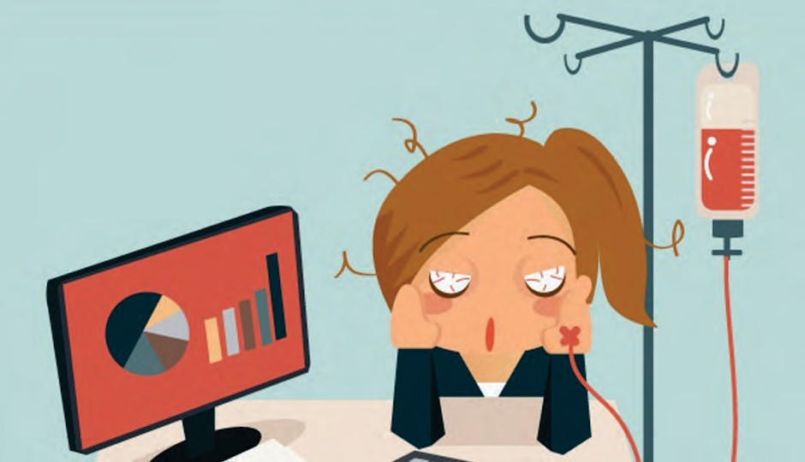

Conclusion

2
Employers should only expect the number of jurisdictions mandating paid sick leave to grow. The concern with the hodgepodge of sick leave laws popping up across the country is, of course, ensuring compliance, particularly for companies that operate in multiple locations. Employers need to do a lot of homework and fully understand all the nuances before implementing any policies or practices regarding sick leave. At a minimum, when a paid sick leave law is passed, a covered employer should be proactive and generally do the following:
- Create a paid sick leave policy or update an existing paid time oﬀ (PTO) policy;
- Customize the policy to ﬁt business needs. For example, determine what “beneﬁt year” to select (e.g., calendar, anniversary, tax or ﬁscal year), whether leave should be accrued or provided in a lump sum, whether to cap accrual;
- Evaluate whether the current policy aligns with the requirements of the new law when updating an existing PTO policy.For example, check whether the current PTO policy: applies to all of the employees that the new law covers (e.g., part time, seasonal); permits employees to use PTO for the same reasons required by law; restricts the use of paid sick leave in ways the new law does not (e.g., does not allow for carryover);
- Review attendance policies and make sure they do not penalize employees for taking leave that is protected by law or another company policy;
- Obtain and post any required notices;
- Create a method for tracking leave time (if using an accrual method) to ensure accrual requirements are met (e.g., update timekeeping and payroll systems);
- Watch for the interaction of the paid sick leave law with other federal, state and municipal leave laws. Track all time concurrently, if applicable (and be careful not to if the law prohibits it);
- Implement record keeping and notice processes (e.g., who an employee should notify, timing of notiﬁcation and how to recoup paid sick leave that is unsupported by proper documentation);
- Reach out to staﬃng companies and conﬁrm each party’s compliance responsibilities, if the paid sick leave law also covers temporary workers; and
- Train HR, payroll personnel, managers and supervisors on the requirements of the new law.

The industry an employee is in and whether or not employees are unionized impact the availability of paid sick leave, according to the BLS study. For example, employees in management, professional and related ﬁelds are far more likely to receive paid sick leave (82%) than employees in the service industry (42%). Union workers also fare better than nonunion workers (76% of union workers receive paid sick leave as compared to 63% of nonunion workers).

