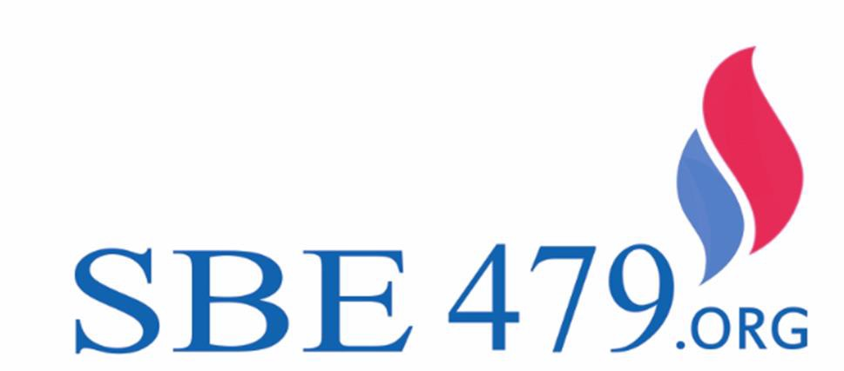

EXTENDED THROUGH 2019

WORK OPPORTUNITY TAX
CREDIT (WOTC)

Hiring Incentives!
Currently servicing over 40,000 locations for all available federal, state and local hiring-related tax credits

This federal tax credit reduces the federal tax liability of employers who hire individuals from target groups. These individuals are considered to face barriers to hire, target groups include:
•Veterans
•TANF Recipients
• Ex-felons
• SNAP (Food Stamp) Recipients
• Designated Community Residents (living in federal zones and/or renewal communities)
•Vocational Rehabilitation Referral
• Supplemental Security Income Recipients
• Summer Youth Employee (in Empowerment Zones) • Long Term Unemployed

Credits Available – Do you take advantage of this now?

Receives SNAP (food stamps)
Veteran Eligibility based on disability Hired one year from leaving service Unemployed at least 6 months Unemployed Veterans
At least four weeks At least 6 months
All other WOTC Target Groups:

$2,400

$4,800
$9,600

$2,400
$5,600
$2,400-$9,000

Plus LOCATION BASED INCENTIVES

Many other programs exist at the federal, state and local level as well, that require redundant information. The HIREtech platform can easily integrate most state programs in conjunction with your WOTC screening to maximize your
results. Some examples of federal, state and local programs are listed below:
- Federal EZ
- Training Grants
- Native American Credit

For more information thepeopeople.com
844.479-TEAM

This platform can easily

- Negotiated Incentives

integrate with any existing HR software,

ATS, or On

- Statutory State and Local Programs Boarding system to generate higher results and

reduce on-boarding time.

