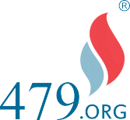

How to Find
Industry Secrets Enclosed Series

the Right PEO for
Your Company-
and Determine If a PEO Is
Even Your Best Option

Learn how to save on both Medical and Administration fees and get the services and modules you didn't know you could get at no additional cost.

INSIDER’S
GUIDE TO PEOs
BUYER'S
CHECKLIST
LANDMINES TO
AVOID

Secrets About

Not written by the PEOs themselves

PEO Selection Guide: Unravel the Complexity

You've probably heard enough good stuff about PEOs to start wondering if it's the smart move for your mid-sized business. But is it all true?
Top Ten Employer Questions

Can a PEO really reduce my health insurance costs up to 34%? How?
I know a business that saved a lot of money, but how can I be sure we will too?
Will they really protect me from employee lawsuits, and pay to defend them and pay if I lose the suit or get a ﬁne? What about protection from D.O.L. violations?
Can a PEO really provide my employees with better beneﬁts with the major insurance carriers and HRIS systems we wish we had and still save money ?
Are PEOs the obvious path to an affordable future, or a scam?
How can an insurance co-op or buying group be so much less than my broker?
Will the PEO platform technology be easy to use?
Is co-employment as scary as it sounds or not? Do I lose any control or not?

And There Are Dozens More Questions You Might Be Thinking About.

What You'll Learn From this Paper

The point of this paper is not to answer all these questions because the answers are different for most businesses and you can ﬁnd that all over the net.
This paper is not an attempt to sell you on how great PEOs are – it was not written by a PEO.
For some businesses, a PEO is actually not the best solution to their HR, payroll, beneﬁts, and employee administration problems and costs.
For others, they'll be kicking themselves for not joining a PEO years ago.
PEOs are not a one-size-ﬁts-all opportunity.

Instead, this paper will help you ﬁnd out what you can not easily ﬁnd on-line. This paper is designed to tell you facts and INDUSTRY SECRETS .
How do you ﬁnd out the straight forward, objective, and honest answers about PEOs without spending a lot of time going in the wrong direction.

On your own, answering all these questions would exhaust your time and resources beyond your capacity, and truthfully you don't have the expertise.
In this report , you will learn how to answer the fundamental questions about PEOs, and how to turn what is normally a time-consuming and frustrating process into a pleasure.
So let's begin with this: Where can you go to answer these two most fundamental questions?

Fundamental Question #1:
Is a PEO right for me?
Fundamental Question #2:
How do I ﬁnd the best PEO for my business and get the right services at the best price?
The Problem of Growth, Turnover,Increasing Liabilities and Everyday Operations
When it comes to your beneﬁts, payroll, and HR administration, you have to get it right.
Recruitment – retention – engagement – production – 'human capital' and technology combined with incredibly expensive health insurance costs that are continually rising.
Your HR and CFOs manage payroll, admin, hiring, recruiting, training, retention, culture, and your two largest line items – salary and beneﬁts.

Can a PEO really reduce your workload from some of these and save you money at the same time?
A PEO seems to offer a way for businesses to navigate all this growth without it costing them so much time and personnel. It looks like a way to get all your HR done in one place rather than buying each service separately and
save direct insurance costs and indirect costs and liabilities and time. But is it ?

Secret: About one third of the time, the ﬁnancial beneﬁts of switching to a PEO are clear beyond any doubts. But, for another one third of companies, you can be rejected from these Professional Employer Organizations and their buying groups. For the last third, it depends on the speciﬁc details a bit more.

So, if you wanted an honest assessment of whether a PEO is right for your business, where would you turn? Would you try…

Your Insurance Broker, Payroll Provider, or 401k Rep? NO, read why
What would you do if your clients asked you if a competitor was better? And if your competitors offered better prices or more services than you, would you tell this to your customers?

They have no reason whatsoever to help you in your quest to understand PEOs since essentially it replaces them or drastically lowers their margin.

THINK ABOUT THIS FROM THEIR PERSPECTIVE.

If you turn to any of your current 'partners', vendors, or providers for information about PEOs, you're essentially asking them to evaluate their competition.

What most brokers do is either avoid talking to you about PEOs, or try to scare you with terms like “co-employment”, the idea of losing control, some horror story of a fellow client, and other confusing and worst-case scenario information.
So let's address the co-employment question for a moment. It can sound VERY scary – but what is it actually?

Co-employment is a legal term that allows the PEO to share certain administrative responsibilities and allow you to be part of a better insurance buying group. It simply means the PEO is liable for the payroll and a few other functions outlined in the Federal Act called The Small Business Efﬁciency Act #479. It is very different from Joint Employment – but it sounds the same.

You don't give up your right to hire, ﬁre, set policies, market, sell, expand, contract, or anything else related to your business. But you do give the PEO responsibility to fulﬁll some of the hr, payroll, and admin tasks you don't want to do – like taxes or state compliance, or carrier bill payments and reconciliation etc... and this ironically reduces your risk, because the PEO is now liable for all these functions. But yes, it does sound scary. and especially before the federal act made everyone's functions clear, it was a little scary.

If you turn to any of your current 'partners', vendors, or providers for information about PEOs, you're essentially asking them to evaluate their competition AND EARN 75% LESS.

Co-employment is the word your current vendors use to scare you from leaving them for a PEO. It's like how software vendors used to scare you about using the cloud before they had their own cloud versions.

(INSIDE INDUSTRY SECRET) ALWAYS FOLLOW THE
MONEY. Insurance brokers make a lot on your beneﬁts programs, 3-5% of your total premiums every month.
Sometimes they try to get involved in PEOs, but they make about 75% less commissions on PEOs as they do with regular beneﬁts programs. What would you do if you were them? Plus, oddly enough they don't really understand the breadth of what PEOs can do.

Insurance brokers and HR service providers are simply not an objective source of information on PEOs.

So where do you turn instead?

Do you go direct to the source, to the PEO sales rep?
NO!

This at ﬁrst seems to make a little more sense. but remember – there are two questions you're trying to answer: is a PEO the right answer for your company? and, how do you narrow it down to the ﬁnalists you want to closely look at and select?

This is where going directly to the PEO becomes a problem. Here's why:

First and most obvious, they're inherently biased toward both PEOs as a solution (that is what they sell) and toward their own PEO (that is all they sell). Their job is to sell.

A second and less obvious problem is, PEOs can appear complicated (but frankly, they don't have to be - they are a comprehensive way to simplify a very complicated necessity of running a business).

Industry Secret: The complex nature of this means many PEO sales reps simply don't understand the life of an HR manager or CFO and really feel your pain. they are there for one thing - make a sale and move on.

The time you'll invest in going directly to PEOs and doing all the applications and comparisons yourself is dwarfed only by the fear that after all that you still might pick the wrong one.
A third problem with going direct is that now all the work is up to you. If you want to compare ﬁve different PEOs (and how do you choose which 5?), guess what that means?

You have to talk to ﬁve different reps, answer the same questions ﬁve times, be at the mercy of ﬁve different underwriters, send follow up documents, wait, ﬁll out the different forms – how long does all this take?

Many colleges now have a common application. You ﬁll out one application and can use it to apply to dozens of schools. Why can't searching for a PEO be the same way? Why can't there be just one set of forms, one source of answers, and one person to lead you through all this PEO complexity?

Why can't there be just one set of forms, one source of answers, and one person to lead you through all this PEO complexity?

If you try to do all this on your own, then after getting all this information back from the narrowed-down list of PEOs you've chosen, now you have to look at it and really understand it.

That means it's your job to pour over 15-30 page documents of all the beneﬁts of each PEO (and in their proposals the beneﬁts are never apples to apples). This is why the incredible complexity of this industry is such a huge factor in choosing a PEO. You won't even know many of the questions you need to ask in order to negotiate the best deal for you company.

Plus, you'll quickly realize they all say basically the same thing. They all seem to offer the same similar-sounding services. But do they? And how do they deliver their service? Even after all this work, you won't be able to perceive the differences you need to make an informed choice.

Below is a page from a 36-page proposal comparing seven different PEOs. Take a look – they all offer basically the same features. But this doesn't tell you anything useful, like how they feel to work with, how their system integrates with yours, how they match your style and vertical, or if what they show you here is the same as the version you'll get stuck with (some PEOs have multiple platforms).

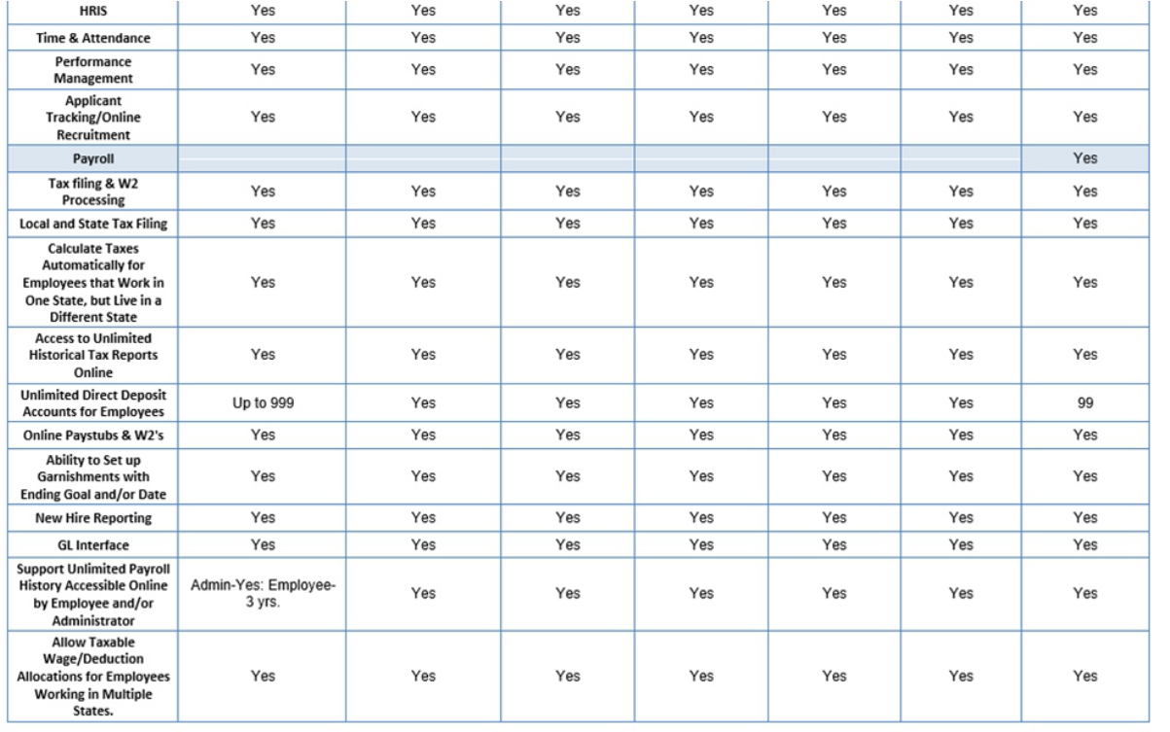
Sample Features Comparison Form Based On Client Current And Future Needs

(Industry secret): Going direct is also actually more expensive - these PEO sales people have quotas of only 300 -
400 employees a year – so they need make a lot per head out of the admin prices and this dramatically increases your costs forever).

Even after going through the hour-long demos from each PEO, you won't have an actionable understand- ing of their differences. So how do you ﬁnd out the truth?
Just reading a few PEOs proposals takes a long time. Understanding them takes even longer. Comparing the PEOs to each other – you'll be working on this for a long time.

And that assumes you understand the differences of how they really operate all these great functions like HR, beneﬁts, compliance, time and attendance, and payroll well enough to accurately evaluate each proposal.

Look at this chart showing some of the functions a PEO performs, BUT HOW DO THEY DO IT REALLY?????

You also may not know all the services they can throw in for free.

The bottom line is, going directly to the PEOs takes way more time.

It offers no certainty that you'll find the best one or get the best service.

It will cost you way MORE.
A fourth problem with going direct to the PEO is, you may not have the best team .Without any clout at the PEO, you have no way to assure yourself that you've got the best team to implement and service your needs.

40% of implementations fail after the salesman sells you and then disappears onto his next prospect.

Choosing the Wrong PEO Has Major Consequences

And you never ever want to have to change after you make this move – you need to make sure you pick the right one

(Again, if a PEO is right for you in the ﬁrst place!)
If you do much digging, you start to realize how impossibly complicated this thing is. Not every PEO can work with every company.

PEOs specialize in:
- Location: speciﬁc states or regions
- Type of industry and how well they know it (like
- HIPAA or OSHA regulations)
- Size of company, with speciﬁc numbers of employees
- Certain service packages
- Cost structure
- Service models – pick and choose, only complete packages, etc
- Rates
- Program features
- Health insurance plans – renewal rates, renewal history, offerings and of course Technology

You can't see this kind of stuff in a benefits list or a sales pitch.

And in addition to all this, what kind of customer service do they have? Every PEO is going to promise terriﬁc customer service. But how do you really know?

And what about their technology platforms and ease of use?
There's nothing worse than telling your employees how excited you are about their new HR services platform and then ﬁnding out they all hate how it works and liked the old one better.

How well does their on boarding process go?
If about 40% of PEOs will fail you during the setup phase, can you do anything to make sure you're part of the 60% that goes smoothly?

Pick the wrong one, and you'll pay too much. You'll get the wrong options. You may get poor ongoing service from people and teams that constantly change.

And you never want to have to change to another one

HR: The Most Complicated Invention
of the Modern Era
What this comes down to is your need for expertise in an industry that has become impossibly complicated. Did you know there are over 700 PEOs – all vying for your business?

Here's a condensed list of typical HR services your company needs that a 479 helps with:

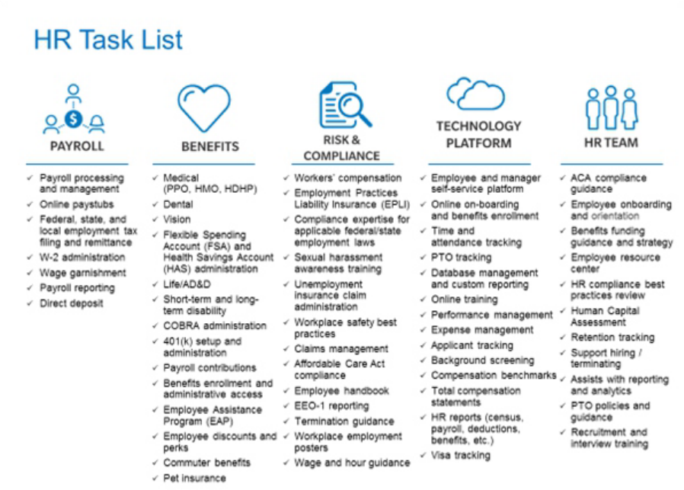

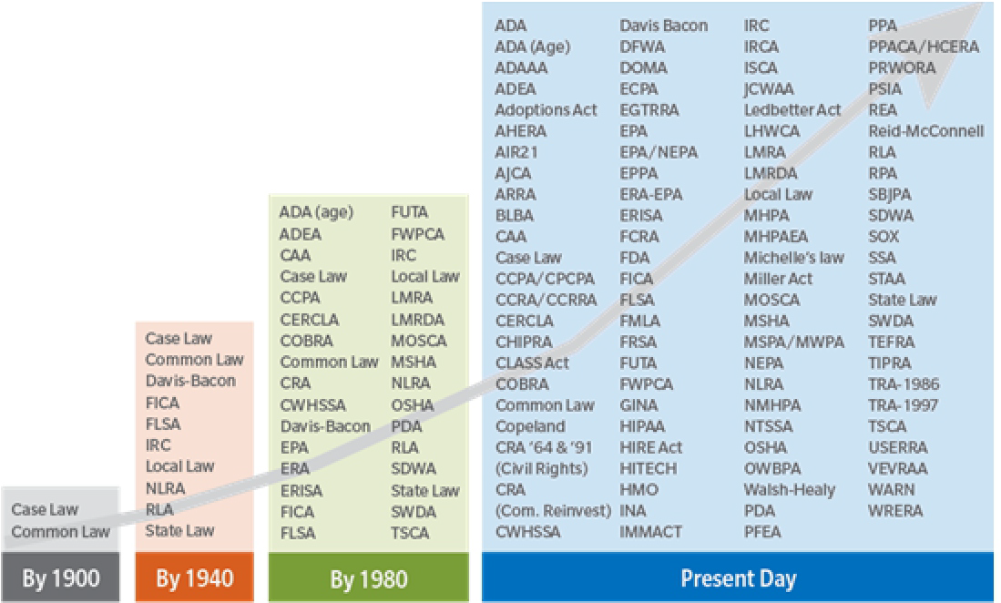WHAT they protect you from

And HOW they protect YOU personally, your company, the owners and the board…

All this varies greatly from one PEO to the next
What about those regulations and compliance?

Here's a chart showing the increase in regulations that businesses have had to comply with over the last 120 years:

Enforcement is here and it's real and increasing.Who is looking out for you and sharing this liability?
Who will deal with employee lawsuits?

The average employee lawsuit (valid or not) costs employers over
$80,000.
There are over 100 sets of laws and regulations and if you don't comply with them, you can be ﬁned, sued, and maybe even forced out of business. 26% of small businesses could be ﬁned every year because of payroll mistakes alone, often because of new tax rules. It's impossible to keep up. Over 38% are non-compliant with beneﬁt disclosures, ﬁlings, and other E.R.I.S.A. and/or D.O.L. regulations, not to mention being at risk for expensive employee lawsuits.

On your own, you have time to spend about half a week on each one to make sure your business is in compliance for the year. Then, you have to start over again on January 1st, because the regulations keep changing.

Here is a basic one: When was the last time you updated your policy manual? Did everyone sign it? Where are your wrap documents?
Did you know that if you are audited by the D.O.L. that this is one of the 62 questions they will ask, and that you have ten days to respond and prove you did all 62?
Who in your company is going to represent you to the D.O.L.?

And then that itch is still there in the back of your mind – what if a PEO isn't right for your business?

If you can't go to your insurance broker, payroll vendor, or the PEO sales rep –
Who is left to call for help?

It's true, none of those people have the objectivity, experience, or expert industry knowledge you need to make an informed choice.

You can't just research it online. You don't have the expertise to do that, let alone the time it would take to do it right.
So, what's left?

There must be a way to figure out the truth
- is a PEO right for you, and who will provide you with a fair analysis?

And if a PEO is the smart move for you, which one is best for your company? We're back to the two fundamental questions.

There must be a way to access all the beneﬁts of a PEO without having to waste so much time in meetings having arguments with your team over details that you never seem to have enough of to help you decide.

There must be a way to ﬁnd the best PEO for your business, with the best rates, the service package that's right for you, the industry expertise you need, the customer service you expect, and a technology platform that's easy to use.

OK – ready for the answer?
The one who can help you is…
A PEO broker/advocate

When your company shops for new health insurance plans, do you call up each insurance company, or do you use a broker who knows the industry? You use a broker even though there are only a handful of health insurance companies left in each market.

They are a third party industry expert who can sift through the complexity and show you which PEOs really are best for you.

There are over 700 PEOs, and the industry is far more complex than health care – that's just one part of what a PEO manages.

A Great PEO broker:

Knows the industry They already know which ones aren't right for your industry, your size, your state, and all the other variables that come into this. They already know which ones are expensive, have problems and others are complaining about and leaving.

Has clout expertise and high-level relationships with every major PEO.

Secures the best rates that will help you realize the kinds of ﬁve and six ﬁgure savings you've heard other

Does a PEO Broker :
Represent YOU
YES
Favor any PEO
No
Obtains better
prices than going direct
YES
Know the right people at the PEO to fix things if they go wrong
YES
Get the right team for your firm
YES

companies get – they work for you not the PEO.

Effectively negotiates on your behalf directly with the PEOs. They use the ﬁnalist PEOs' own quotes against each other to get you the best possible deal.

Asks you the right questions about your dreams and systems and short and long-term needs.

Gets you the best customer service team that will stick with you (see number 2 – they have the clout with the PEOs to demand this for their clients).

Costs less than going directly to PEOs because you pay nothing to the broker and you'll get a lower price for your HR services than you would have otherwise.

Is truly objective and unbiased – their corporate philosophy is in ﬁnding you the best deal, no matter what
– even if that means they tell you a PEO isn't best for you.

Specializes in PEOs – they do this exclusively with a solid infrastructure to make sure each part of the process is done right for you.

A good PEO broker understands how complicated this is, and what's at stake for your company's future.

Stays with you until your needs are met. They persevere through all the complications until you've got the system you want and then throughout the year and every renewal!

Is not an insurance broker saying they are a PEO broker –remember they make twice as much steering you to something other than a PEO.

A good PEO broker understands how complicated this is, and what's at stake for your company's future. He patiently works with you through this – let's be honest – horrible process. No one enjoys picking HR or health insurance or payroll or compliance or time and attendance or on boarding services, etc. But, it's a necessity of the modern world. Not just a necessity however – it can be great.

Try this on your own, and you'll be lost at sea for weeks. Your family will forget your name. Your employees will think you don't care about them. Your customers will think you resigned. Before too long, you'll show up on the back of a milk carton, only to be rescued with bloodshot eyes in your company basement staring at another PEO beneﬁts package or demo.

They can explain to you why these specific PEOs are your best options.
And they have no loyalty or predisposition toward one PEO over another.
Their only interest is in getting you the best deal.

A PEO broker's job is to do the work you can't do and don't have time to do. To show you if a PEO is right for you, and if so, a handful of your best choices.
With a legitimate established PEO broker, you ﬁnally have someone – a professional team, actually–on your side who can relieve you of almost all this endlessly frustrating work. They objectively will ﬁnd you the best PEO choices and present them to you in a way you can understand quickly and be empowered to make a ﬁnal decision.

How are they paid and what is a PEO broker's motivation?

They are all paid like insurance brokers – they get paid by the vendors and most of the vendors pay them all the same. Thus, they have no reason to steer you in any direction other than the best one for your company. And the best brokers absolutely get you better prices than going direct because they get paid less than the PEO direct sales channels. It's a win win for you.

So the ﬁnal question is...
How do you choose the right PEO broker?

Choosing the Right PEO Broker

We talked about it above but we are repeating it because it is the secret to your success and happiness throughout this process.

Here's what you're looking for:
- Clout with the PEOs – all the major reputable ones.

- Has clients similar to you

- Expertise within the industry and all its ever- changing regulations and intricacies.

- A PEO - exclusive broker specialist, not an insurance broker who dabbles in PEOs on the side.
- Honest, direct, objective, and clear.

- Uses one approved universal form that covers everything

Just one set of forms to ﬁll out one time. The universal form is critical to saving you time in this process. It saves you from ﬁlling out different forms for every PEO you're interested in.

A good broker should be able to show you how they make the process easy and have added value to your business, not wasted your time.

Some PEO brokers will have their prospects sign a 'letter of intent' or there's some kind of back end savings they get even if you don't go with that PEO. That's a red ﬂag.

As mentioned earlier –you'd think buying directly from PEOs would be less costly than going through a broker. But in reality, the reverse is true. A PEO broker can negotiate with multiple PEOs and secure you the lowest rate from the best PEO for your company. They have clout and access.

The potential beneﬁts of PEOs are clear, but may not be right for you. But we hope you have a clearer picture now about the process of selecting one and determining if it's the right option

What should you do next?

Here's a quote from a business owner in North Carolina. Notice that he doesn't just talk about how a PEO broker got him a better deal than going directly to the PEOs.

“It was amazing actually. I shopped direct for PEOs. I got quotes. Then we found SBE479. Within a week they reduced the quotes from the PEOs we were thinking about by literally $30 a month per employee. For our ﬁrm with 90 employees this meant an annual savings of
$32,400. They also got us a quote from one of the large PEOs that was another $25 a head less. Another $27,000 a year savings.(not to mention over $100,000 reduction in medical premiums)”

One of the largest, oldest, PLATINUM level PEO brokers is a company called SB479.org.

They have been doing this work for 20 years – and started this company and process because they had the same frustrations for themselves as their clients. They sponsored this thought guide for employers like you.

WHY SBE479.org?

SBE479.org is one of the largest and oldest PEO brokers in the country. They can and will deliver on every single promise you've read here.
  - They have the industry expertise, buying power, and long experience to negotiate the best possible deals.
  - They know which PEOs are best, and which ones to avoid.

  - They know which ones specialize in the areas that relate to your business, such as companies that have to comply with OSHA or HIPPA.
  - They represent every major certiﬁed PEO and will give you honest and clear comparisons of just 2 or 3 that are your best options
  - They are patient and will walk with you through this, however long it takes.

  - They are honest enough to tell you if a PEO isn't actually your best option. And in that case, they will 'll still help by directing you to the best health insurance, liability and other services you'll need that will integrate with your current systems.
And, they get better prices and services for you as fast as it can be done.

Click the button below and set up a call with SBE479.org.
Schedule My Call with a PEO Broker
Or call them directly at 1-844-479-TEAM

We hope this guide was useful.
For more information on PEOs click here as well.

