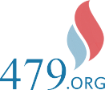
America’s Largest Small Business Buying Group

power AofBRthIEeFFIENDTERROADLUACCTTIOSN47T9OKTnHoEwn As
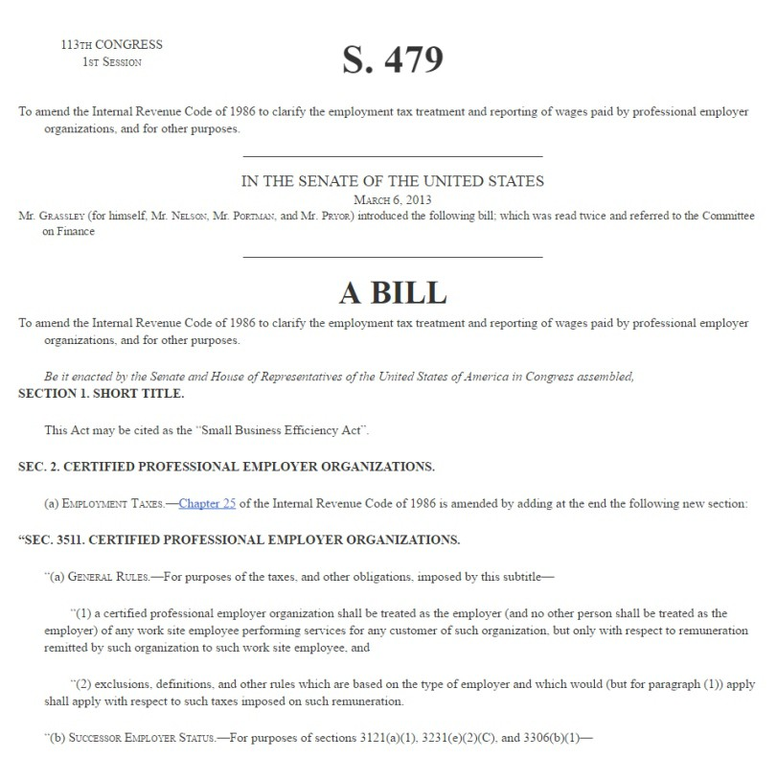SMALL BUSINESS EFFICIENCY ACT

What kind of companies take advantage of this plan?

Over 130,000 employers in the United States take advantage of this program including, but not limited to, such firms as:

D J\
L\L(

IER,i l
1 T l \l : ( T\TLHS
LOCATIONS NATIONWIDE

·

- \ \'

S J-I OPR UNNE;: R
0

l ov e it . get i t.

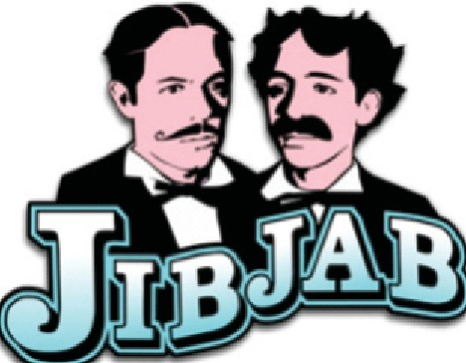
1flowers.com
"\ 1800

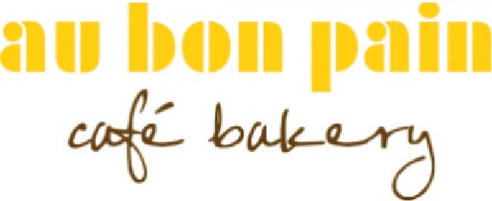
¥

-freshdired
T &Co.

NATIONAL M U S EU M O F

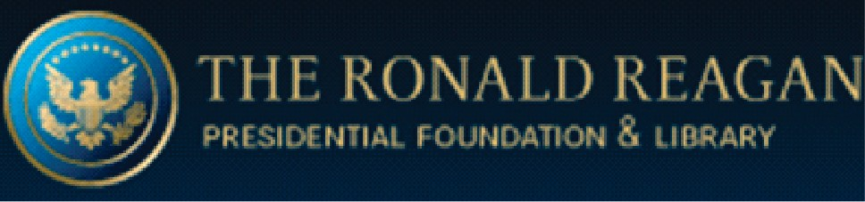
AMERICA JE Wl SH H ISTORY
V, IC TORIA'S
SECRET

G A R M I N•M,

The Background:
Before this legislation, large company buying groups were assisting small and medium sized firms in operating better by sharing Fortune 500 type tools and access to lower cost, products and se rv ice s. These options were offered to both member companies and to their employees. However under the existing tax code at the time, it was unclear whether these larger employer groups could actually offer some of these advantages to their member groups or to their employees, since they were not actually part of them. In addition to this it was unclear that if certain liabilities occurred, who would the responsible party for these liabilities be - including any penalties and fines that may be incurred.
The purpose:
This act was to create a certainty and clarity regarding the I.R.S., O.S.H.A., E.E.O.C. and D.O.L. positions surrounding these questions. Employers that joined these 479 organizations needed unambiguous comfort of the protections afforded by these programs. This congressional approval of Act 479 has now made it clear that the advantages of these buying groups are codified and real.

The ultimate goal:
479 was to provide additional options, tools and processes for American businesses to be more competitive and efficie nt . In fact, the actual name of the act is The Small Business Efficiency Act.

How was this accomplished?
The ACT now clearly allows certified 479 organizations to literally share their E.I.N. number (their Employer Tax Identification Number) with member employers. By doing this the larger group becomes liable as the employer of record for tax and other liability purposes, including employer tax liabilities, for the smaller member groups.

This transfer and the acceptance of these liabilities to the 479 plans:
Include all the penalties, fines and lawsuits as any employer would have --encompassing a range of business risks from sexual harassment and discrimination lawsuits, to wage payment improprieties and even extends to situations in which the owners and executives may be personally liable as officers and fiduciaries, etc.
Furthermore, this 'sha ri n g' of the E.I.N. now allows the smaller groups to access the buying power and technology systems of these larger groups - for instance this often, but not always, can dramatically reduce the cost of health benefits, worker's comp benefits, and cost of HRIS systems, payroll, time and attendance systems, paperless on-boarding, etc.

The Effect:
So Far over 130,000 small employers have joined one of the 900 Certified 479 programs across the United States, representing approximately three million employees. In addition to this Federal Act that helps American Businesses, several States have also passed statues that mirror the Federal Act.

SBE479oRGI

SBE 479.aR^{I}G

SBE479.ORG is a community outreach organization paid by and sponsored by certain approved and certified 479 providers.
Our function is help make small and medium sized businesses become aware of this fundamentally important and potentially game changing legislation.
It was passed by Congress for a good reason - to make American Businesses more competitive and more profitable by reducing risk to owners, liabilities and red tape to small and medium companies, and to do things you just couldn't do before this law. These advantages stem from a very simple concept - allow smaller business access the buying power and systems of larger companies and to also allow you to actually relieve yourselves of various liabilities and responsibilities.
Make no mistake about this - it is important.
But like so many important things, who really has the time to explore them when you are running a business and you and your people are struggling with things that just waste your time, are distracting, inefficient and expensive.
Our job is to call your attention to this opportunity so you will realize this is one of those meetings you should take. These meetings aren't from sales people selling you on saving 5 cents on a copy or 2% on whatever. This is about truly increasing your net buy over $1,453 per employee, increasing your sales by 11 % on the average, and even being happier. Remember it was so meaningful that it is one of the few things our Congress agreed on.
Another function of SBE479.org is to learn enough about your business to direct the most appropriate 479 firm to you at that appointment. Your time is valuable and this is potentially very important, so we also act as moderator and concierge for you. There are a number of these firms each having different rules, styles, targets and specialties, and who has time to meet with a bunch of companies, even if they are all great?
Another function SBE479.org provides are pre-negotiated discounts and rates for our groups.

Why haven't I heard about this program?

From my P&C broker, from my health insurance broker, from my payroll company, from my outside counsel?

Why do you think? The truth is this act provides all these programs through one organization, one vendor, and it is not them and they cannot do it all. They can't provide lower rates with carriers because of the ACA and carrier rules - these organizations can. They cannot and certainly would not accept your liabilities, pay penalties and fines, or defend you and your company in litigation. These organizations can and do. So if you were them, would you tell your customers about a solution in which you would lose your fees, commissions, premiums etc. This ACT answers those questions for you!
This is disruptive to them the way Uber is disruptive to the Taxi and Limousine Industry and Amazon is to brick-and-mortar retail.

It Just Seems Too Good To Be True. What's the Catch?
The programs are restricted to certain eligible companies?
In order to qualify for these savings and services, each Member Company MUST meet the following requirements:
  - You must have more than 12 full-time employees working over 30 hours a week.
  - The average salary must be over $23,000 for those employees.
  - Your company must be in business for more than three years.
  - Your company must not be in one of the restricted industries.

Note: to be underwritten for this select risk pool there are NOindividual underwriting questions like with several other plans.

    - Relief of liabilities including penalties and fines from DOL, OSHA, EEOC, AND OTHER GOVERNMENT AGENCIES
    - "Who you gonna call when you are audited by the DOL" - 479 organizations take care of this
    - Reduction of Worker's Compensation up to 30% and in some cases dividend eligible even for small groups
    - Reduction of Group Health Insurance Premiums on the average 16%
    - Lower Group Insurance Renewals - averaging 4% to 5%
    - Ability to provide other Fortune 500 benefits without administration
    - Decreased employee turnover by 23% according to industry averages
    - 50% higher survival rate of startups who use these programs
    - Access to integrated operating systems that increase efficiencies, reduce wasted busy work, reduce liabilities, and reduce costs directly and indirectly
    - Provides better buying power and negotiation leverage for various services by accessing larger buying group.
    - Provides business owners additional sleep insurance by transferring and sharing the fiduciary
liabilities that often can pierce the corporate vail.

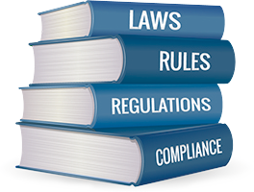

Are you complying with all these Acts?

- Age Discrimination in Employment Act ("ADEA")
- Americans with Disabilities Act ("ADA")
- Title VII of the Civil Rights Act of 1964 as amended (Equal Employment Opportunity laws) ("EEO")
- Equal Pay Act ("EPA")
- Consumer Credit Protection Act ("CCPA")
- Fair Credit Reporting Act ("FCRA")
- Consolidated Omnibus Budget Reconciliation Act ("COBRA")
- Employee Retirement Income Security Act ("ERISA")
- Family and Medical Leave Act ("FMLA")
- Genetic Information Nondiscrimination Act ("GINA")
- Patient Protection and Affordable Care Act ("PPACA" or the "Healthcare Reform Act")
- Fair Labor Standards Act ("FLSA'')
- Immigration Reform and Control Act ("IRCA")
- Occupational Safety and Health Act ("OSHA")
- Uniform Services Employment and Reemployment Rights Act ("USERRA")
- Worker Adjustment and Retraining Notification Act ("WARN")
- State and local laws and regulations

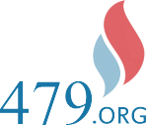
America’s Largest Small Business Buying Group

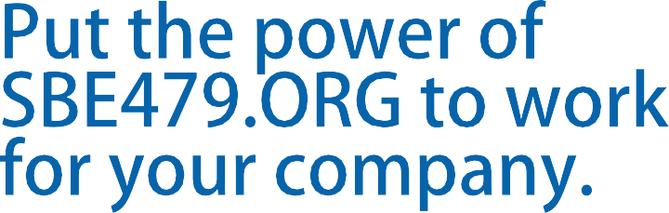

To learn more about how SBE479.ORG can support your organization: _{VISIT} _{US} _{ONLINE}

CONTACT US DIRECTLY
Speak with a SBE479.ORG representative at 844.479.TEAM.
Or email us at: info@sbe479.org

