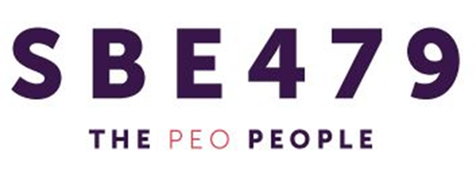

The Department of Labor (DOL) published the annual adjustments for 2019 that increase certain penalties applicable to employee benefit plans.

Annual Penalty Adjustments For 2019

The following updated penalties are applicable to health and welfare plans subject to ERISA

Description  Failure to file Form 5500  Failure of a MEWA to file reports  Failure to provide CHIP Notice  Failure to disclose CHIP/Medicare Coordination | 2018 Penalty Up to $2,140 per day Up to $1,558 per day  Up to $114 per day per employee  $114 per day per violation | 2019 Penalty Up to $2,194 per day Up to $1,597 per day  Up to $117 per day per employee  $117 per day per violation
to the State | (per participant/beneficiary) | (per participant/beneficiary)
Failure to provide SBCs | Up to $1,128 per failure | Up to $1,156 per failure
Failure to furnish plan documents  (including SPDs/SMMs) | $152 per day  $1,527 cap per request | $156 per day  $1,566 cap per request
Genetic information failures | $114 per day | $117 per day
De minimis failures to meet genetic information requirements | $2,847minimum | $2,919 minimum
Failure to meet genetic information requirements  – not de minimis failures | $17,084 minimum | $17,515 minimum
Cap on unintentional failures to meet genetic information requirements | $569,468 maximum | $583,830 maximum

Employer Action

Private employers, including non-profits, should ensure employees receive required notices timely (SBC, CHIP, SPD, etc.) to prevent civil penalty assessments. In addition, employers should ensure Form 5500s are properly and timely filed, if applicable. Finally, employers facing document requests from EBSA should ensure documents are provided timely, as requested.

